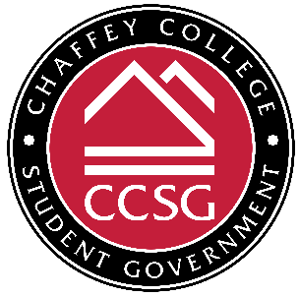
Finance Committee Meeting
Monday, October 10, 2022 | 12:30-1:15pm | Online via Zoom
Meeting Link: https://chaffey-edu.zoom.us/j/87197357380
Meeting ID#: 871 9735 7380 | Call In #: +1 669-900-6833

NOTICE IS HEREBY GIVEN that CCSG Finance Committee will hold a REGULAR meeting. CCSG reserves the right to suspend the order of the agenda at any time if necessary to conduct business. Further notice is given that CCSG reserves the right to record the meetings as it sees fit and use it for business as needed.

- CALL TO ORDER
- VOCAL ROLL CALL OF ATTENDANCE

- CHAIR: Director of Finance: Joette Chavez-Lares
- Director of Events: Tamia Newman
- Senator: Joseph Foss
- Dean of Student Affairs: Chris H. Brunelle

- APPROVAL OF PREVIOUS MINUTES
- APPROVAL OF AGENDA
- PUBLIC COMMENTS*
- GUEST SPEAKER(S)
- EXECUTIVE/SUB-COMMITTEE REPORTS

- Dir. of Finance
- Dir. of Events
- Dean of Student Affairs

- UNFINISHED BUSINESS
- NEW BUSINESS
  - Review Finance Committee Bylaws & Budget – Dean Brunelle will review and discuss the Finance Committee Bylaws.
  - Review Funding Requests vs. Bill Process – Dean Brunelle will review and discuss the funding request process and the bill proposal process.
  - Review Club Funding Process & Announcement – Dean Brunelle will review and discuss the club funding process and email to chartered clubs.
- INTRODUCTION OF BILLS
- CONSIDERATION OF CONSENT AGENDA
- ANNOUNCEMENTS
  - The next Finance Committee meeting is on Monday, October 24 @ 12:30-1:15pm.
- ADJOURNMENT

*CCSG is required in accordance to the Brown Act to allow the public to comment on agenda items before or during consideration by legislative body (54954.3 Ch. IV & V). Comments are limited to three minutes per speaker and fifteen minutes per topic or action item, if there is more than one speaker. It is not required for action to be taken nor is it required for extended discussion of any items not on the agenda. At the conclusion of public comment, CCSG may ask the members to review a matter or may ask that a matter be put on a future agenda. For further information and anyone who requires a disability-related modification or accommodation to participate in the public meeting should contact CCSG at (909) 652-6590 as far in advance of the CCSG meeting as possible.

