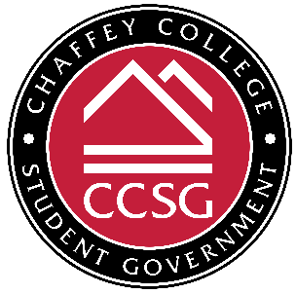
Delegations Committee Meeting
Monday, October 10, 2022 | 1:15-2:00pm | Online via Zoom
Meeting Link: https://chaffey-edu.zoom.us/j/87197357380
Meeting ID#: 871 9735 7380 | Call In #: +1 669-900-6833

NOTICE IS HEREBY GIVEN that CCSG Delegations Committee will hold a REGULAR meeting. CCSG reserves the right to suspend the order of the agenda at any time if necessary to conduct business. Further notice is given that CCSG reserves the right to record the meetings as it sees fit and use it for business as needed.
- CALL TO ORDER
- VOCAL ROLL CALL OF ATTENDANCE

- Chair – VP of Administration: Delancy Christion
- President: Rousselle Douge
- Senator: Ramia Chaudhary
- Senator: Jasmin Duarte Alvarado
- Senator: Demia Lotson
- Senator: Jennica Valencia
- Faculty Advisor: Professor Charles Williams
- APPROVAL OF PREVIOUS MINUTES
- APPROVAL OF AGENDA
- PUBLIC COMMENTS*
- GUEST SPEAKER(S)
- EXECUTIVE/SUB-COMMITTEE REPORTS

- Dir. of Delegations
- President
- Faculty Advisor

- UNFINISHED BUSINESS
- NEW BUSINESS
  - Committee Goals – VP Christion will discuss committee objectives and assign research tasks to committee members.
  - Special Meeting for CCCSAA Application Review – The committee will schedule a time to meet to review the CCCSAA applications, if the trip is still feasible.
  - Town Hall Meeting – VP Christion will lead a discussion on planning a town hall meeting for the Fall semester.
- INTRODUCTION OF BILLS
  - Bill # 10.2022.1 – $7,000.00 – To pay for the registration fee for the 2022 California Community College Student Affairs Association (CCCSAAA) Student Leadership Conference for students and advisor.
  - Bill # 10.2022.2 – $4,000.00 – To pay for roundtrip ground transportation to the CCCSAAA Student Leadership Conference from Rancho Cucamonga, CA to San Diego, CA for students and advisor.
  - Bill # 10.2022.3 – $10,000.00 – To pay for lodging for the to the CCCSAAA Student Leadership Conference in San Diego, CA from 10/21/22-10/23/22 for students and advisor.
  - Bill # 10.2022.4 – $1,500.00 – To pay for the per diem (meals) for the CCCSAAA Student Leadership Conference attendees at $55 each.
- CONSIDERATION OF CONSENT AGENDA
- ANNOUNCEMENTS
  - The next Delegations Committee meeting is on Monday, October 24 @ 1:15-2:00pm.
- ADJOURNMENT

