Accessing Horizon via a Web Browser (Recommended)

Chaffey is committed to your access to software you may need while completing course work. We have set up open virtual labs for students to access software such as Microsoft Office, Adobe, and more. Logging in to our Horizon site allows you to access all these software programs at no cost to you.
This virtual lab is accessed by using a generic username and password, it is not what you would typically use to login to other systems at Chaffey. This service is exclusive to registered Chaffey students, to locate the generic username and password, please login the Student Hub via Canvas Virtual Lab resource page. Please note, if you are enrolled in a course that requires specialized software, your instructor will provide you with a specific username/password for your class.

Steps to access Chaffey’s Virtual Lab (via Horizon)
- Launch your favorite browser and go to the following URL, https://horizon.chaffey.edu/
  - Please note, the following web browsers are supported for HTML Access 4.8:
    - Chrome
    - Chrome for Android device
    - Internet Explorer 11
    - Safari
    - Safari on mobile device iOS 10 and iOS
    - Firefox
    - Microsoft Edge

- From the Horizon landing page, click on “VMware Horizon HTML Access”
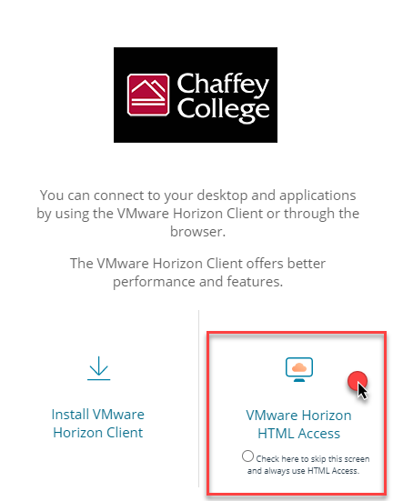
- Enter a username and password (please login the Student Hub via Canvas Virtual Lab resource page for more information)
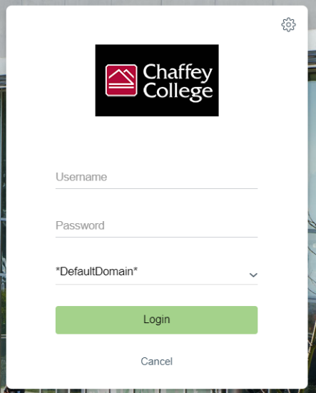
- Select the desktop pool and you will connect to a machine if ones available.
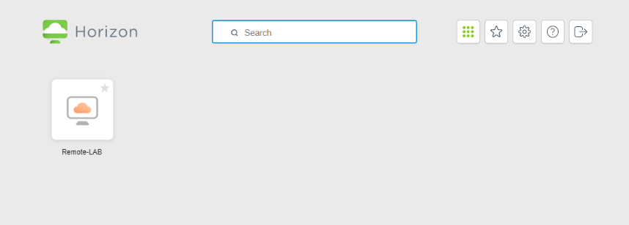
- If you receive an error that states "All available desktop sources for this desktop are currently busy. Please try connecting to this desktop again later, or contact your system administrator," it means that other students may be logged in the the virtual lab and you may have to try again at a later time. Think of this as "walking" into a computer lab on campus and there is no open seats/computers available. However, if you experience this error more an extended period of time, please contact our IT Help Desk at isrepairs@chaffey.edu.

Steps to Log Out of the Virtual Lab Space
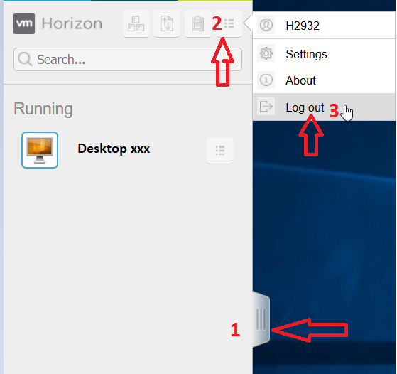
- Click on the tab (1) to expand the Sidebar
- Click on the menu (2)
- Click Log Out (3)

